EXPERIMENT NO. 4
Information Gathering using theHarvester

Tool Used | theHarvester 4.2.0

Platform | Kali Linux

Target Domain | www.zoho.com
AIM
To gather open-source intelligence (OSINT) about a target domain — such as subdomains, IP addresses, ASNs, and interesting URLs — using theHarvester tool in Kali Linux.
TOOLS REQUIRED
- Kali Linux (with theHarvester pre-installed)
- Internet connectivity to query public search engines and OSINT sources
- Terminal access
THEORY
theHarvester is a reconnaissance tool used to gather information about a target domain from publicly available sources such as search engines, PGP key servers, and OSINT platforms. It helps a penetration tester build a profile of the target's external attack surface by collecting subdomains, email addresses, IP addresses, ASNs, and employee names without directly interacting with the target's infrastructure.
PROCEDURE
Step 1: Open a terminal window in Kali Linux.
Step 2: Run theHarvester with the required flags: -d to specify the target domain, -l to limit the number of results, and -b to specify the search engine/source (use "all" to query every available source).
Step 3: Optionally use -f to save the gathered results to a report file.
COMMAND FLAGS
Flag | Use | Example
-d | Domain / remote site to fetch information from | theHarvester -d www.zoho.com
-l | Limit the number of search results | theHarvester -l 300
-b | Specify the data source / search engine to use | theHarvester -b all
-f | Save the output report to a file (html/xml) | theHarvester -f test

Command used: theHarvester -d www.zoho.com -l 300 -b all
OUTPUT
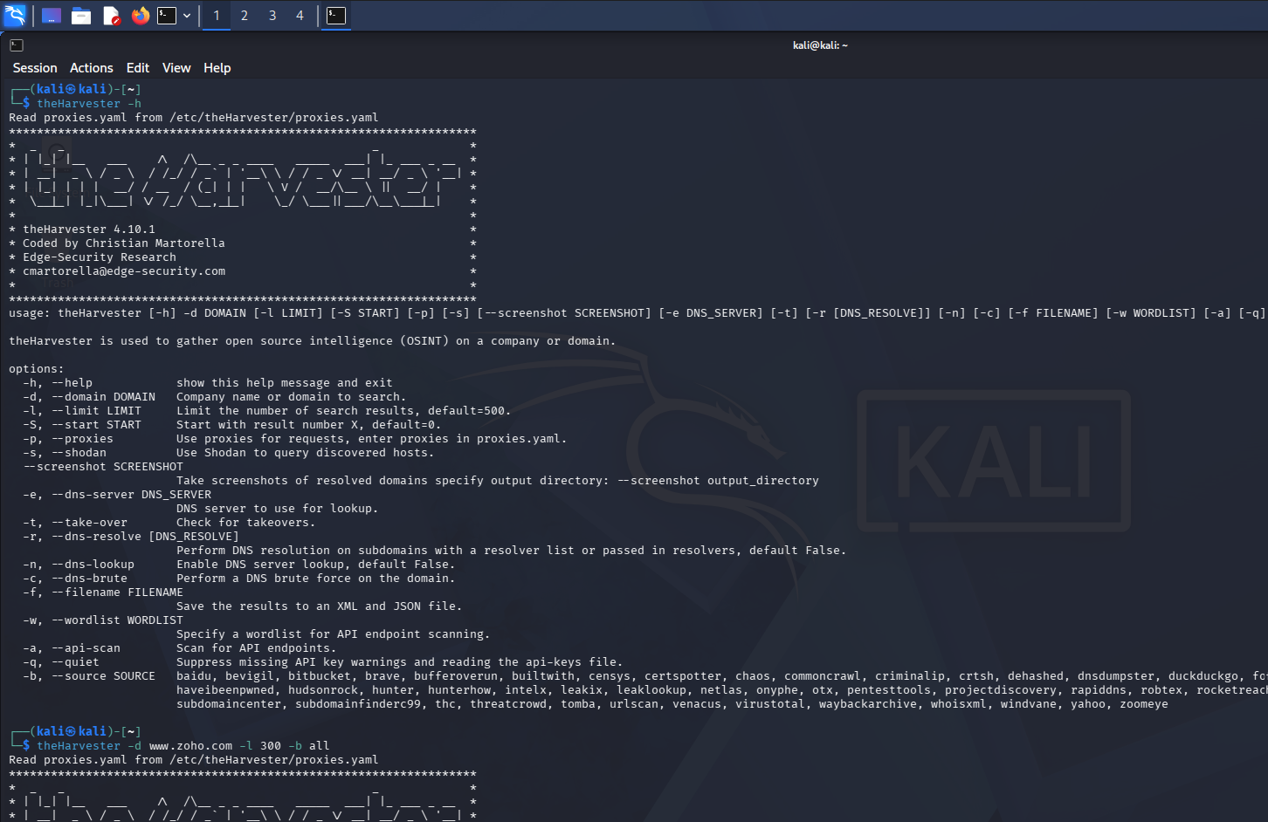

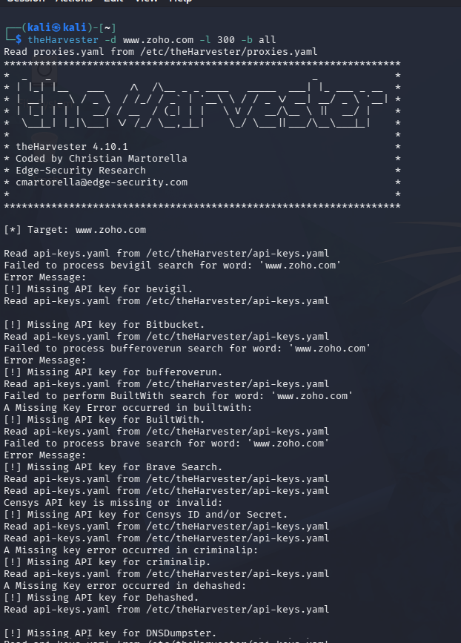

RESULT
Thus, open-source information about the target domain www.zoho.com — including ASNs, interesting URLs, and IP addresses — was successfully gathered using theHarvester tool.

